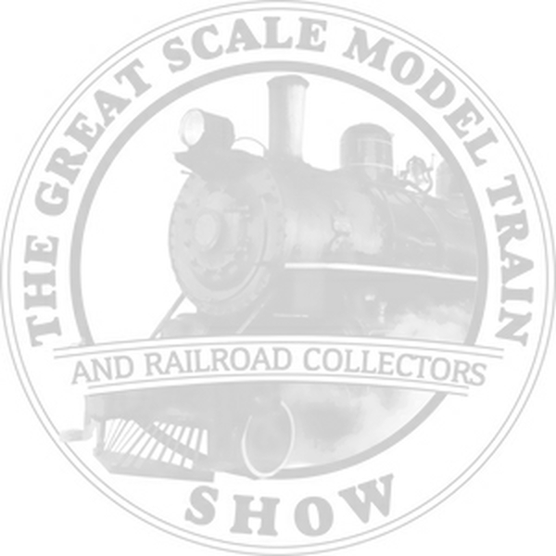

**The Great Scale Model Train Show**

Dealer’s Courtesy Discount Admission Coupon

Maryland State Fairgrounds 2200 York Rd. Timonium MD 21093

Take $2 **OFF** a Solo Adult Admission

(Pay $7 instead of $9)

Show Dates & Info at gsmts.com

Take $3 **OFF** a Family Admission

(Pay $15 instead of $18)

|  |  |  |
| --- | --- | --- |
| Visitor Name | Zip Code | Email |

Courtesy of:



**The Great Scale Model Train Show**

Dealer’s Courtesy Discount Admission Coupon

Maryland State Fairgrounds 2200 York Rd. Timonium MD 21093

Take $2 **OFF** a Solo Adult Admission

(Pay $7 instead of $9)

Show Dates & Info at gsmts.com

Take $3 **OFF** a Family Admission

(Pay $15 instead of $18)

|  |  |  |
| --- | --- | --- |
| Visitor Name | Zip Code | Email |

Courtesy of:



**The Great Scale Model Train Show**

Dealer’s Courtesy Discount Admission Coupon

Maryland State Fairgrounds 2200 York Rd. Timonium MD 21093

Take $2 **OFF** a Solo Adult Admission

(Pay $7 instead of $9)

Show Dates & Info at gsmts.com

Take $3 **OFF** a Family Admission

(Pay $15 instead of $18)

|  |  |  |
| --- | --- | --- |
| Visitor Name | Zip Code | Email |

Courtesy of: